The Hare and the Tortoise
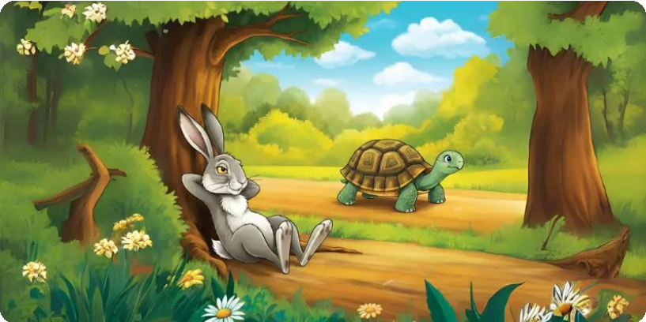
Once, there was a hare who was best friends with a tortoise. The hare was very proud of how fast he could run, so one day, he challenged the tortoise to a race. The tortoise agreed, even though everyone thought he was way too slow to win. The race began, and the hare raced so fast that he was far ahead of the tortoise.
Feeling confident, the hare decided to take a nap under a tree while the tortoise kept going, step by step. When the hare woke up, he was shocked to see the tortoise crossing the finish line. The tortoise had won the race!
Moral of the story: It doesn’t matter how fast or strong you are—what matters is being steady and never giving up. And don’t be too proud, it can cause trouble!

The Dog and the Bone
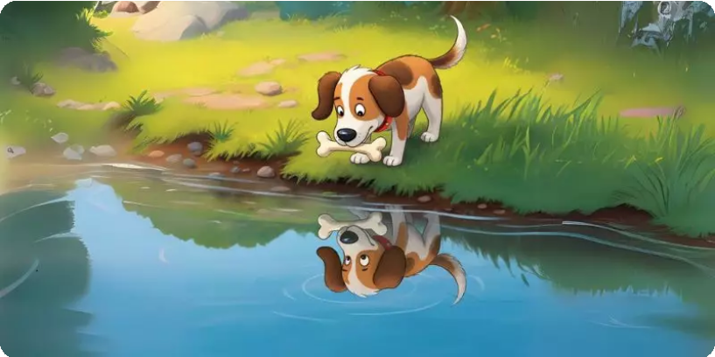
One day, a dog found a big, tasty bone. He was so excited that he grabbed it and ran to find a quiet spot to chew it in peace. While
crossing a river, he looked down and saw his reflection in the water.
But the silly dog thought it was another dog with another bone!
Greedy for more, the dog barked to snatch that “other” bone. But as soon as he opened his mouth, his own bone dropped into the water and sank. The poor dog lost it all and had to go home with nothing.
Moral of the story: If you’re too greedy and always want more, you might lose what you already have.

The Thirsty Crow

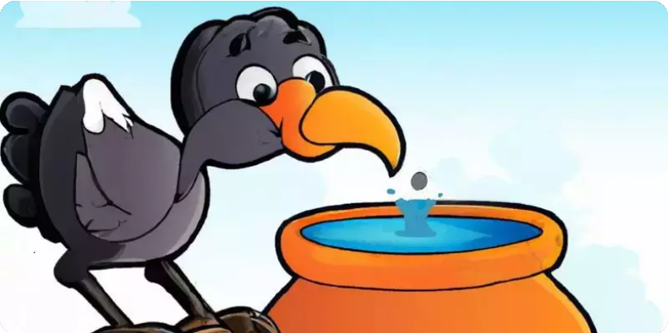
A thirsty crow was flying through a forest, looking everywhere for water. Finally, he saw a pot with some water at the bottom, but his beak couldn’t reach it. The crow didn’t give up. He looked around and noticed some pebbles on the ground. The clever crow started dropping the pebbles into the pot one by one. Slowly, the water rose higher and higher until it was close enough for him to drink. The crow finally quenched his thirst and flew away happily.

Moral of the story: You can solve any problem if you think smart and don’t give up!

Lazy John
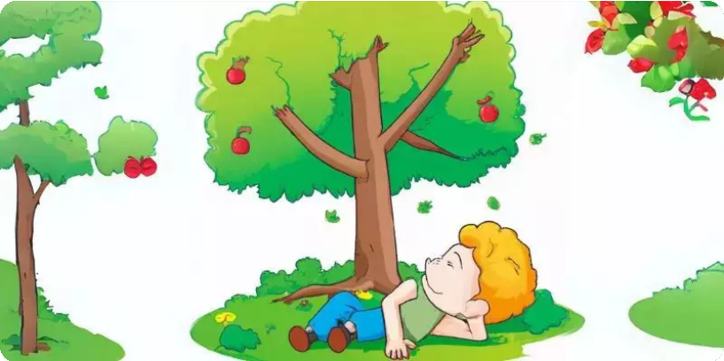
There was a boy named John, and he was the laziest boy in the entire town. One day, John saw their apple tree full of shiny red apples. He wanted to eat some but was too lazy to climb the tree. Instead, he lay on the grass and waited for the apples to fall down on their own. But, of course, the apples didn’t fall, and soon John was very, very hungry because he hadn’t worked for his food.
Moral of the story: Laziness won’t get you anywhere. You have to work hard to get what you want!

The Fox and the Grapes

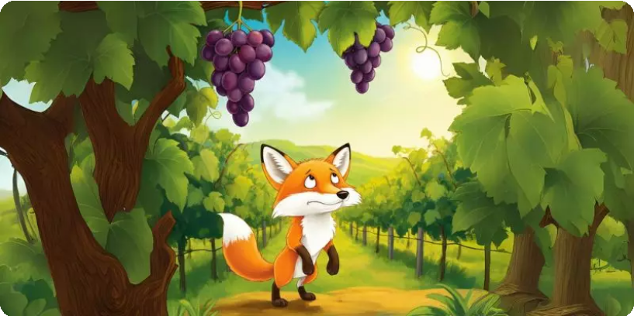

A hungry fox was walking past a vineyard when he saw some ripe, juicy grapes hanging from a vine. They looked so delicious! The fox jumped high to grab them but couldn’t reach them, no matter how hard he tried. Tired and frustrated, the fox walked away, grumbling, “Those grapes are probably sour anyway!” But deep down, he knew he had just given up too quickly.

Moral of the story: Don’t make excuses when something is hard— keep trying!

The Ant and the Grasshopper
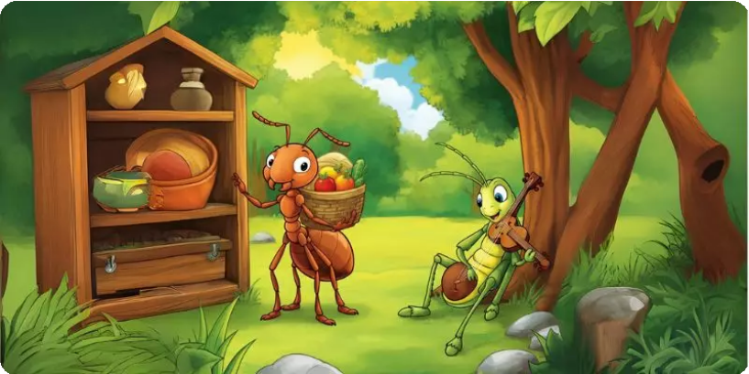

One summer, an ant worked hard every day to gather food and store it safely for the winter. His friend, the grasshopper, however, laughed and said, “You work too hard! Relax!” The grasshopper spent all summer playing and singing instead of preparing.

But when winter came, the grasshopper was cold and hungry, while the ant stayed cozy in his home with more than enough food.

Moral of the story: Always plan ahead and be prepared. Life won’t always be easy, so take care of your needs while you can.

The Boy Who Cried Wolf

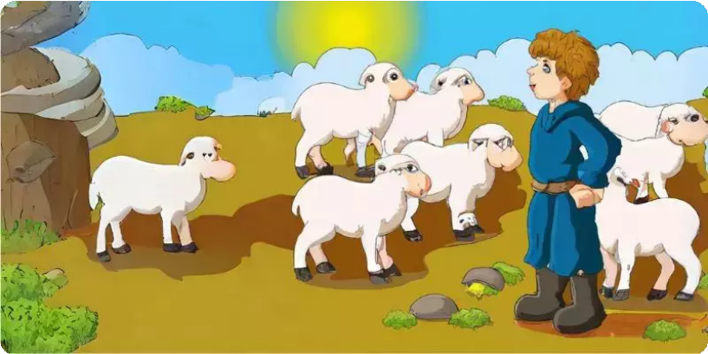

There was a young boy whose job was to watch over the village sheep. One day, he was bored and wanted some fun, so he shouted, “Wolf! Wolf!” The villagers came running to help, only to find the boy laughing at them because there was no wolf. The next day, he did it again, and the villagers were angry. Later, a real wolf came and started attacking the sheep. The boy cried, “Wolf! Wolf!” But this time, no one believed him, and the wolf ran off with some sheep.

Moral of the story: If you keep lying, no one will trust you—even when you’re telling the truth!

The Ugly Duckling

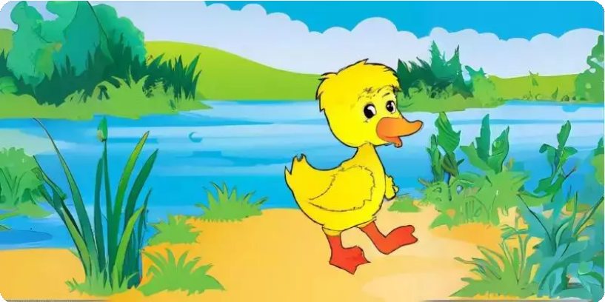

A little duckling was born looking very different from his siblings. The other ducklings called him ugly and made fun of him. Feeling like he didn’t belong, the little duckling ran away and searched for a place where he could be accepted. Seasons passed, and one day, he saw his reflection in a lake. To his surprise, he had grown into a beautiful swan! He wasn’t an ugly duckling at all—he had just been different all along.

Moral of the story: Don’t judge someone by how they look. Everyone is special in their own way, and real beauty is about being yourself.

9. The Lion and the Poor Slave
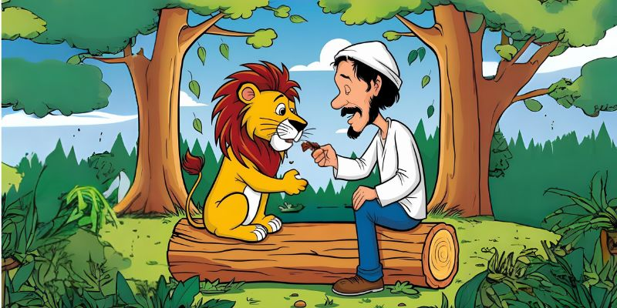
A kind slave ran away from his cruel master and hid in the forest. There, he saw a lion roaring in pain because a big thorn was stuck in its paw. Even though he was scared, the slave helped the lion by pulling the thorn out. The lion went back into the woods, free and happy. Later, the slave was caught and sent to be punished by being thrown into a lion’s den. But the lion didn’t harm him—it was the same lion he had helped!
Moral of the story: A good deed is never forgotten. Be kind, and kindness will come back to you.

10. The Elephant and the Ants
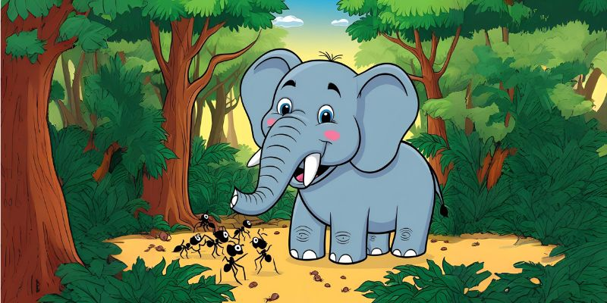
A big, proud elephant loved bullying smaller animals. Every day, he sprayed water at the ant hill, making life difficult for the tiny ants. One day, the ants decided to teach him a lesson. They crawled into his trunk and started biting him from the inside! The elephant danced and howled in pain until he begged for forgiveness. He promised to never hurt the ants or anyone else again.
Moral of the story: No one is too small to make a difference. Be kind to everyone, no matter how big or small they are.

